Build a LAN topology in Cisco Packet Tracer
1.star topology
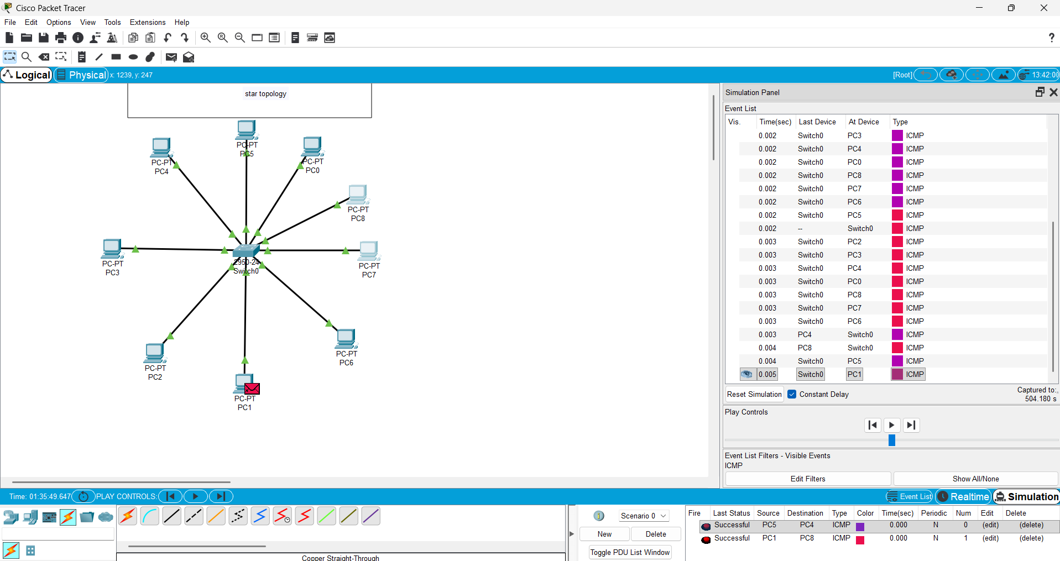
(ii): Implementation of Mesh topology
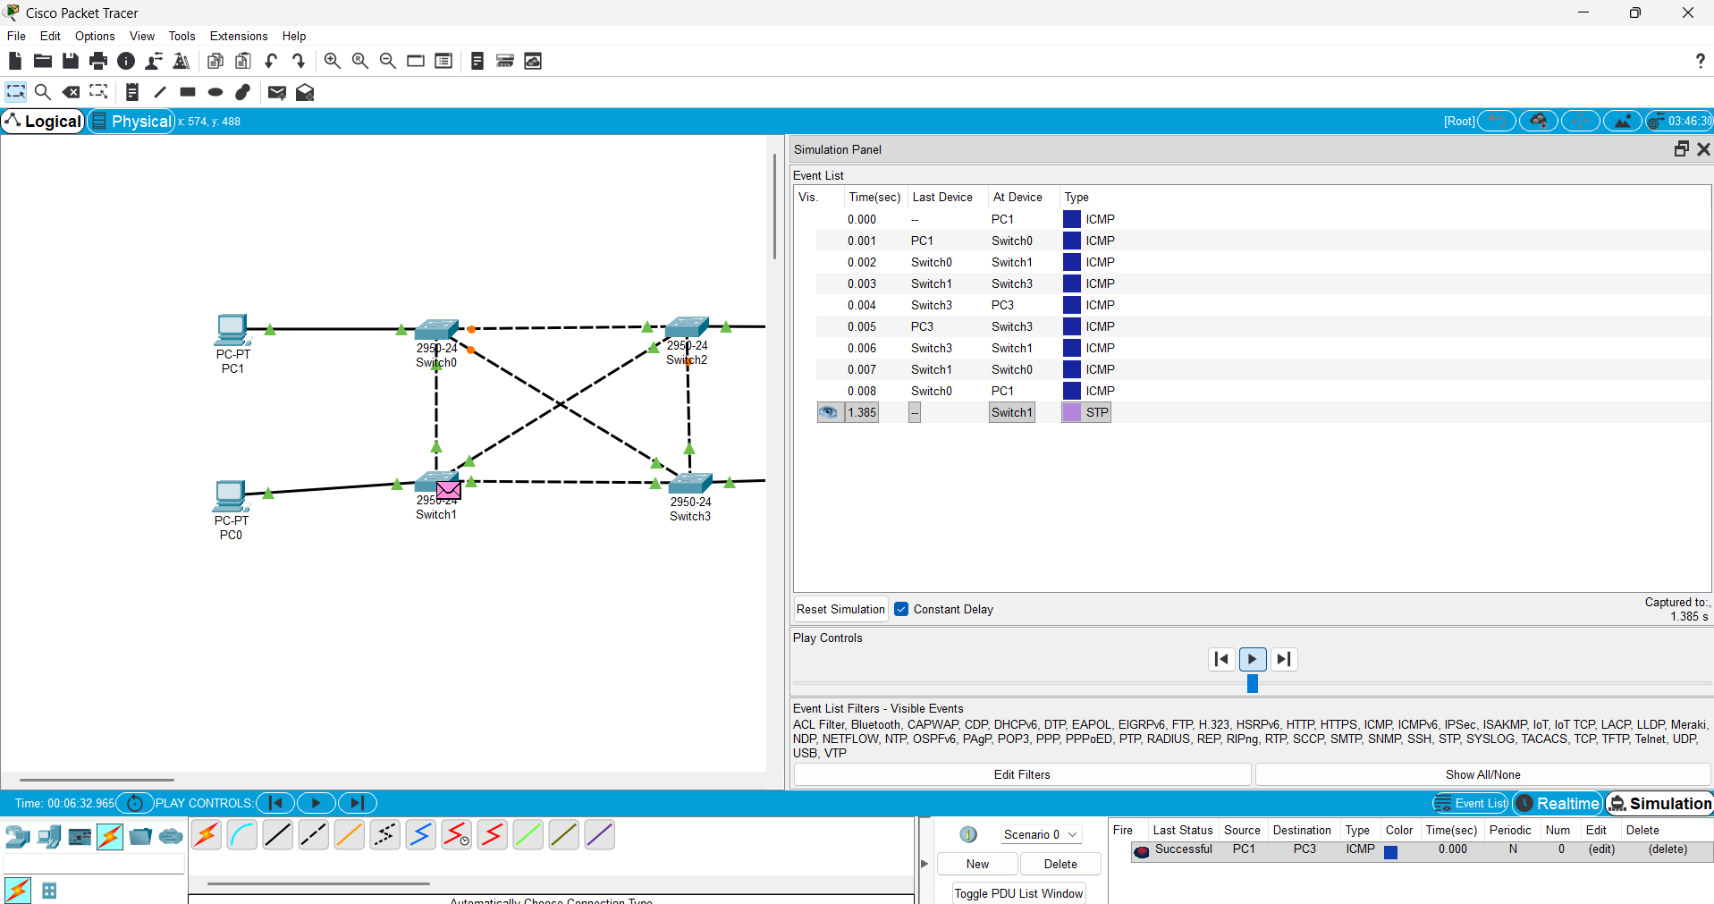

Objective (iii): Implementation of Hybrid Topology
